**AN ONLINE RETAIL STORE**

The retail store is a technology company that is a market place and payment service, operating globally. The logistics service enables the delivery of packages through local partners while the payment services facilitate the payments of online transactions. It has partnered with more than 100,000 sellers and individuals.

The business has been performing well and the management wants to analyze what the major contributing factors are to the revenue so they can strategically plan for next year.

The leadership is interested in viewing the metrics from both an operations and marketing perspective. Management also intends to expand the business and is interested in seeking guidance into areas that are performing well so they can keep a clear focus on what’s working.

Both, the executives are interested in viewing and understanding how they can use the data to make more meaningful decisions. You would need to provide insights which they can use to create the expansion strategy. The executives want to analyze the trends and the breakdown by different categories so that they have clarity on how the revenue is being generated and what are the main factors affecting the online store.

**Objective**

The primary objective is to analyze the major contributing factors to revenue for the technology company, which operates as a marketplace and payment service globally Africa. The analysis will help management strategically plan for the next year by identifying key trends and areas of success, enabling informed decision-making for business expansion.

**Methodology**

Data collection: The data was gotten from forage virtual internship program. It contains 8 columns and 541,909 rows in total 4,198,746 datasets for both row and columns.

**Analysis Process**

The analysis process involve:

1.The data cleaning process: This process involves removing any form or irregularity in the data, which could make the data not suitable for usage or could give wrong analysis. This process involves 7 steps which include

* Accuracy
* Completeness
* Uniqueness
* Consistency
* currency
* Relevancy
* Validity

But for this project, focus will be on just three (3) which are

* **Accuracy (Correct Values):** A unit price is supposed to be below 0. In the unit price column, it is filled in with some negative values which is not suppose to be part of the data. It contains 2 rows. Also, the quantity column should not be below 1 (one) unit which are found in 10,624
  + **Remedy**

1. Removing the values which are below 0 from the unit price column.
2. Removing from the quantity column datasets that are below 1 unit.

* **Completeness (Data fields with Values no missing values):** In the description and customer id Columns, they are filled in with empty space also called *null* values.
  + **Remedy**

1. Removed the null values from the Description column provided which amount to 1,454 data values.
2. Also, for the customer id column 135,080 rows are empty which I didn’t removed all of them. I only remove those with no Description which amount to 1,454 rows.

* **Relevancy**: in the Description column, it contain some irrelevancy values Such as *,??? Etc.
* **Remedy**
  + - 1. They were all removed from the data sets.

Afterall the data cleaning process, the dataset remaining for further analysis were 397,927 rows and in total 3,183,400 dataset values

**2. Tool**

1. Excel 2019 with power Query editor.
2. Power bi - for the visualization.

**Key Metrics and KPIs:**

* Which region is generating the highest revenue and lowest?
* What is the Monthly trend of revenue, which month faced the biggest increase and decrease?
* Which Month generate the most revenue?
* Who is the top Customer?
* What revenue is been generated from customer who order more than once?
* Top 10 Performing Products?

**Detailed Analysis**:

* **Stock Code Performance:** "DOT" outperformed other Stock Codes in revenue, while "23084" struggled.
* **Geographic Distribution:** The UK dominates the market, followed by the Netherlands.
* **Quantity-Revenue Correlation:** Higher sales volumes generally lead to higher revenue.
* **Market Divergence:** EIRE has a higher average selling price compared to quantity sold.
* **Performance Trends:** Stock Code performance experienced a decline followed by a significant recovery.
* **Quantity Growth:** A prolonged period of quantity growth occurred between June and November 2011.

FIG

* **Dotcom postage (**DOT) outperformed other Stock Codes in revenue, while Rabbit Night light (23084) struggled among the top 10

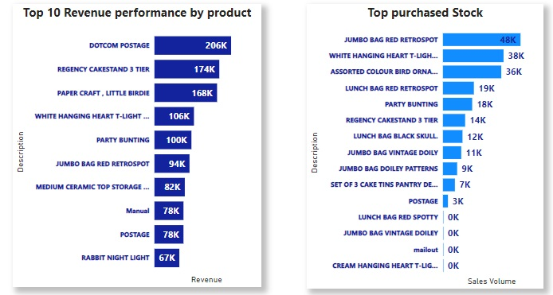

* **Geographic Distribution:** The UK dominates the market, followed by the Netherlands. While Saudi Arabia is the least among them all with 145.92 revenue.

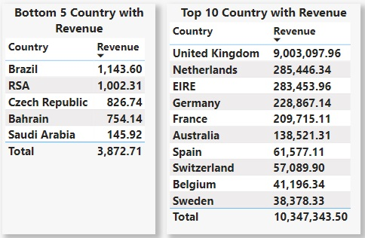

Sales Trend: A prolonged period of quantity growth occurred between June and November 2011.

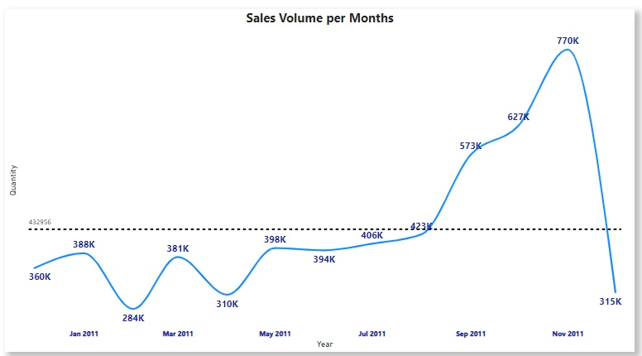

**Summary:**

The analysis reveals that the Stock Code "DOT" outperformed others, while the United Kingdom generated the highest revenue, emphasizing the need to focus on top-performing products and key markets. There's a positive correlation between quantity sold and revenue, particularly in regions like the Netherlands, presenting opportunities for targeted growth strategies. EIRE indicates that the region generates high revenue despite lower sales volume. This suggests that customers in EIRE may be willing to pay higher prices, making it a strong candidate for premium pricing strategies. Also, understanding the trends in Stock Code performance and prolonged quantity growth will be essential for sustaining future business expansion.

**Recommendation:**

1. **Market Expansion:** Given the Netherlands' strong performance, further expansion into this market could be highly beneficial. Leveraging successful strategies from this region and applying them to similar markets may also yield positive results.
2. **Product Focus:** The significant performance of the JUMBO BAG RED RETROSPOT suggests that doubling down on this product, perhaps through targeted marketing or expanding its availability, could drive even greater sales. Similarly, focusing on high-revenue products like DOTCOM POSTAGE could enhance overall profitability.
3. **Customer Segmentation:** With such a significant disparity in revenue per customer, segmenting customers based on their purchasing behavior and targeting high-value segments with personalized offers or loyalty programs could improve customer retention and increase revenue.
4. **Revenue Optimization**: In regions like EIRE, where revenue significantly outpaces quantity, exploring premium pricing strategies or expanding the range of high-value products could further capitalize on this trend.

**Further Analysis Recommendations**

Conducting a more in-depth analysis to determine the customers life time value of high-revenue customers. Also, analyze underperforming markets like the bottom 5 countries to uncover obstacles to entry. To Develop customized marketing and product strategies to increase market share.